**Calculating a Window Air Conditioner’s Coefficient of Performance**

**MEMS 1042 Preliminary Report- Summer 2020**

*Team 5: Michael Albright, Alan Browning, Casey Cadman, William Gleeson*

1. **Introduction**

The goal of our test is to measure the coefficient of performance (CoP) for a window AC unit. This is done by calculating either the heat absorbed or heat rejected by the AC unit and comparing it to the power required to operate the unit. With this in mind, we have developed two test methods for calculating CoP: one that finds the heat absorbed by measuring properties of air flow outside the AC unit, and one that finds the heat rejected by measuring properties of the refrigerant inside the unit. The first option would require sensors to measure temperature, humidity, air flow, and power. The second option would require sensors to measure temperature, pressure, refrigerant flow, and power. The purpose of this report is to compare these options in greater detail by narrowing down specific sensors, estimating cost, and estimating the predicted uncertainty of each setup. For the sake of estimation, we are assuming we are working with an “affordable” LG window air conditioner (Model #: LW6019ER).

1. **Method 1: Air Cycle**

*Sensors*

The first method of measuring the CoP of a window AC unit is to measure the amount of air entering/leaving the unit and relating the temperature difference to the heat absorbed. For this, we need to know the density of air, the velocity at which the air is entering the AC unit, the cross sectional areas of the inlet/outlet, and the temperature of the air. Most of these are straightforward to measure, but the density of air changes with humidity. For this reason, we plan to force the air to go through a “screen” of water to achieve 100% humidity. That way, we only need a humidity measurement at the outlet, reducing our total uncertainty. The sensors we’ve picked for these measurements are shown in Table 1 below. The expected ranges were determined from the AC unit spec page [1].

*Table 1: Selected Sensors for CoP Air Cycle Method*

|  |  |  |  |  |  |
| --- | --- | --- | --- | --- | --- |
| **Property** | **Sensor** | **Brand/ Make/Price** | **Expected Range** | **Operating Range** | **Uncertainty** |
| Temperature | Precision Thermistor Element | Omega  Item #44004  ($24.13 ea) | 15.5-32.2 °C | 0-70 °C | ± 0.1 °C |
| Velocity | Air Velocity Sensor | Siemens  QVM 62.1  ($210.00) | 0-4 m/s | 0-5 m/s | ± 0.2 m/s + 3% measured value |
| Humidity | Digital Humidity Sensor | Honeywell  Humidicon HIH8000 Series  (Not available) | 15.5-32.2 °C | -40 to 125 °C  Q > 20 L/min | ± 2.0% RH |
| Voltage &  Current | Multimeter | Fluke  ($199.99) | 115V  4.4A | 600V max  10A max | 1%  1.5% |
| Area | 48” Aluminum Ruler | Harbor Freight | 0-20” | 0-48” | ⅛” |

The sensors listed above in Table 1 were chosen based on their accuracy and operating ranges. A separate temperature sensor was selected due to its high accuracy in the expected temperature ranges. The velocity sensor by Siemens was chosen because it maintains accuracy at lower flow rates. The humidity sensor chosen operates below 95% RH, which is fine considering a humidity sensor will only be used at the outlet of the AC unit. A robust multimeter will be used since the expected ranges fall well within the operating ranges. Lastly, a ruler was chosen to minimize costs--somewhat--because digital multimeters that measure upwards of 20” are more expensive; and the small gain in precision does not justify it. We believe that the cost of the other sensors listed is reasonable; and the sensors were chosen for their abilities, less so cost.

*Test Fixture*

The planned test setup for this method is shown in Figure 1 below. The AC unit itself will rest on a table and will be split between two rooms of insulated walling (made of wood and styrofoam). For measuring air flow, we will place two air ducts at the front of the unit: one for the inlet (top), and one for the outlet (bottom). To facilitate the 100% humidity mentioned earlier, the bottom duct will be rigged such that water can drip down through the entrance. The temperature, humidity, and flow sensors can simply be mounted in/on/through the ducts. The power supply and sensors to measure power input can be located near the AC unit and can have it’s cords fed outside the enclosed room; along with any other measurement or DAQ wires.

|  |  |
| --- | --- |
|  |  |

*Figure 1: Test fixture for CoP air cycle method. Outside (left). Inside (right).*

*Uncertainty*

Equation 1 is the equation for the coefficient of performance of a refrigeration cycle.

|  |  |  |
| --- | --- | --- |
|  |  | (1) |

Where,

is the coefficient of performance

is the heat flow into the evaporator

is the electrical work into the compressor

The fundamental assumption of this method is that the heat transferred between the air and refrigerant is near 100%. From this, we can consider the from the evaporator to be a function of the change in the thermodynamic properties of the air:

|  |  |  |
| --- | --- | --- |
|  |  | (2) |

Where,

is the mass flow rate

is the heat flow into the evaporator

h is the specific enthalpy

A slight nuance in this setup is the fact that air often carries moisture. This can substantially affect the thermodynamic properties of the air. To work around this issue, we consider an air-water mixture rather than just air. Properties of air-water mixtures are simply the sum of air’s properties and the water’s properties. An equation for can be expanded to the following:

|  |  |  |
| --- | --- | --- |
|  |  | (3) |

Given that the setup is run in a near atmospheric pressure, the thermodynamic properties of the air can be found by using only temperature sensors. The properties of the water can be found using the same temperature sensors in addition to a humidity sensor. Unfortunately, all humidity sensors measure relative humidity; whereas we need absolute humidity to find thermodynamic properties. Thus, we relate relative humidity to absolute humidity:

|  |  |  |
| --- | --- | --- |
|  |  | (4) |

Where,

is the relative humidity leaving the ac unit

is the absolute humidity leaving the ac unit

is the partial pressure of the air

is the partial pressure of the water vapor

is the total pressure, which is assumed to be atmospheric (101.3 kPa)

is the saturation pressure of the water at a given temperature

By using this equation and the definition of specific heat, we can expand our equation for . Furthermore, the mass flow rate of the air is not directly measured, but rather a function of density, velocity, and cross sectional area. With all this in mind, we can express our heat flow using only measurable variables (and documented empirical data):

|  |  |  |
| --- | --- | --- |
|  | ] | (5) |

Where,

Cp is the specific heat of dry air (averaged between inlet and outlet temperatures)

is the change in temperature between in inlet and outlet

is the density of air at the outlet

A is the cross sectional area of the outlet

v is the measured velocity of the air at the exit

The second quantity needed for CoP--from Equation 1--is the electrical work of the system, which will be measured using a multimeter. The electrical work is defined by Equation 6.

|  |  |  |
| --- | --- | --- |
|  |  | (6) |

Where,

is the electrical current

V is the electrical voltage

To calculate the total uncertainty of the system, we can consider Equation 1, 5, and 6. Equation 7 is the general percent uncertainty equation and Equation 8 is the percent uncertainty of our measurement system. In the uncertainty equation, is the absolute uncertainty of variable x.

|  |  |  |
| --- | --- | --- |
|  | , | (7) |

|  |  |  |
| --- | --- | --- |
|  | (...) | (8) |

Using Equation 8 and Table 1, we found the total design stage uncertainty of the air flow method to be **9.59%**. Note: intermediate steps for deriving and calculating uncertainty were omitted for brevity. Full documentation is available upon request.

*Other Equipment*

Apart from the sensors, the other equipment needed will be the materials for the test fixtures (wood, styrofoam, table, water tank/piping, air ducts), a power supply, a DAQ, and the AC unit itself. The power supplied will come directly from a wall outlet instead of a testbench supply. We would want a DAQ that has at least three channels, and none of the measurements are expected to be outside typical voltage ranges, so we decided on a 4-channel DATAQ Model DI-2008.

1. **Method 2: Refrigeration Cycle**

*Sensors*

The second method of measuring the CoP of a window AC unit is to take multiple measurements of the refrigerant at several points in it’s cycle. An AC unit works as a standard refrigeration cycle as pictured below, Figure 2. The AC unit chosen for the experiment uses R410A as the refrigerant, which will experience unique high and low pressures. The low pressure line is expected to experience an approximate pressure of 120 psi and an approximate temperature of 42.5°F [2]. The high pressure line is expected to experience an approximate pressure of 415 psi and an approximate temperature of 117.5°F [2]. An expected flow rate is estimated to be 0.81 liters per minute, which was calculated from expected pressures, temperatures, electrical input, and the assumption of an ideal refrigeration cycle. Realistically, the flow rate would be higher than this value.

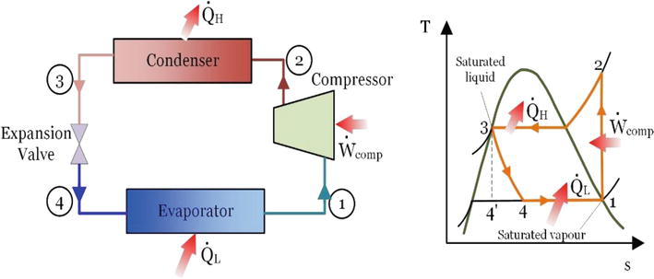

*Figure 2: Refrigeration Cycle [3]*

The sensors required for this experiment can be seen in Table 2. When selecting sensors it was important to find ones that could survive the temperatures and pressures. Because so, we chose temperature and pressure sensors made specifically for measuring refrigerants in these types of systems. The flow sensor was not made specifically for refrigerants, but the allowable operating ranges indicate that the sensor is suitable. The sensors will have to be attached to the cycle by brazing T-joints into the system at their corresponding locations. A multimeter will be used to measure the voltage and current being drawn by the AC unit; this is expected to be 115V at 4.4 amps. Because we needed sensors suitable for refrigerants, we had little choice in cost.

*Table 2: Selected Sensors for CoP Refrigeration Cycle Method*

|  |  |  |  |  |  |
| --- | --- | --- | --- | --- | --- |
| Sensor | Brand/Model | Location | Expected Value | Operating  Sensor Range | Uncertainty |
| Industrial Temperature Sensors | AmphenolGE-1920  ($20.73 ea) | State 3 and 1 | 42.5 -117.5 °F | -40 - 212 °F  0 ~ 435 psig | 1.3% |
| Refrigeration Pressure Transducer | Kavlico  p158-500a-c2c  ($150.26) | State 1 | 120 -415 psig | 30°C to +100°C  0-500 psia | 2% |
| Liquid Turbine Flowmeter | Omega  FTB-1301  ($1,359.00) | State 3 | .81 L/min | .3 - 1.5 L/min  5000 psi  185°F | 1% |
| Multimeter | Fluke  115 Field Technicians Digital Multimeter  ($199.99) | Power Cord | 115V  4.4A | 600V max  10A max | 1%  1.5% |

*Uncertainty*

To perform an uncertainty analysis for this system we will make two assumptions: the expansion valve is ideal (constant enthalpy) and State 3 is a saturated liquid. The state numbering convention will be consistent with Figure 2 above.

The expression for heat flow is shown in Equation 9 below. Consequently, the uncertainty of the heat flow into the evaporator is dependent on the uncertainty of the refrigerant’s mass flow and enthalpy change. Because of our assumption of an ideal expansion valve, we can say that h3 = h4. Furthermore, the mass flow rate can be expressed as Equation 10.

|  |  |  |
| --- | --- | --- |
|  | = | (9) |
|  |  | (10) |

Where

is the mass flow rate of the refrigerant

is the volumetric flow rate of the refrigerant

is the density of the refrigerant

is the enthalpy of state x

The percent uncertainty of the mass flow can be determined using the uncertainties of flow and density. The uncertainty of flow is simply the uncertainty of the flow sensor. However, there is no sensor for density, so we will estimate it as a function of temperature. Equation 11 represents this function and is valid for saturated liquid R410a at temperatures of 10-60°C; density is given in units of . Thus, we can express percent uncertainty of mass flow as Equation 12. This was calculated to be 1.6%.

|  |  |  |
| --- | --- | --- |
|  |  | (11) |

|  |  |  |
| --- | --- | --- |
|  |  | (12) |

Determining the enthalpy of a state outside the vapor dome requires at least two known, independent properties. We expect state 1 to be a superheated vapor, and we can find the enthalpy of this state by knowing its temperature and pressure. Since there is no direct relationship between these properties, we will estimate the enthalpy uncertainty as some average of the pressure and temperature uncertainties, seen in Equation 13. Because we assume that State 3 is a saturated liquid (i.e. quality = 0), we can find the enthalpy from just a temperature measurement; and we can again estimate the percent uncertainty of enthalpy as that of temperature (Equation 14).

|  |  |  |
| --- | --- | --- |
|  |  | (13) |

|  |  |  |
| --- | --- | --- |
|  |  | (14) |

Like the previous method, CoP is calculated from Equation 1 and electrical work is calculated from Equation 6. With all the uncertainties of all individual properties known, we can determine our total percent uncertainty using Equation 15. The total design state percent uncertainty of this experiment is found to be **3.6%**. Again, details were omitted for brevity and full documentation can be provided upon request.

|  |  |  |
| --- | --- | --- |
|  |  | (15) |

*Test Fixture*

The test fixture for this refrigerant method is similar to the air cycle method in that the AC needs to be split between two insulated rooms; the walls again being made of wood and styrofoam. However, there is no need for air ducts, so these “rooms” can be the size of the table top--greatly reducing the total size of the test fixture compared to that of the air cycle method. Aside from the same power supply and power measurement, all the sensors will be internal to the AC unit. Unfortunately, this entails breaking the existing refrigerant line and brazing T-joints to house the sensors. This would most likely be done by a professional. The test fixture for this method is shown in Figure 3 below.

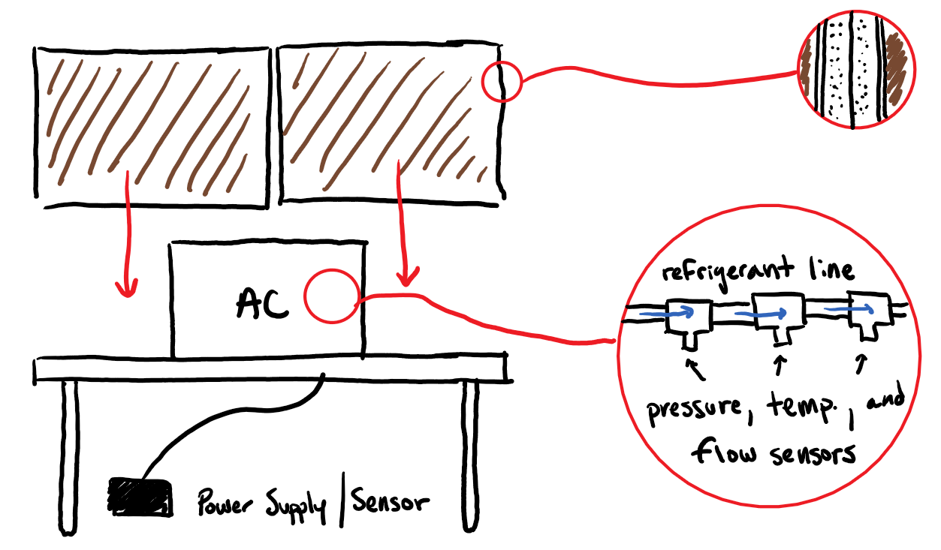

*Figure 3: Test Fixture for CoP refrigerant method.*

*Other Equipment*

The other equipment for this method mostly matches those for the air cycle method. We need the materials for the test fixture (wood, styrofoam, table, T-joints), the power supply, the DAQ, and the AC unit itself. Additionally, we need to pay for the service that will install the T-joints into the refrigerant line. Again, the power supply would be a simple wall outlet and the DAQ doesn’t need to be anything specialized. However, the DAQ does need more than four channels, so we would use a 8-channel DATAQ Model DI-2008.

**References:**

[1] LG LW6019, Air Conditioning Unit.

<https://www.lg.com/us/air-conditioners/lg-LW6019ER-window-air-conditioner>

[2]Air Conditioner Compressor & Refrigerant Pressure Readings.

<https://inspectapedia.com/aircond/Refrigerant_Pressures.php#410A>

[3]**Shaimaa Seyam,** Faculty of Engineering, Benha University, Benha, Egypt

Sensors:

* Liquid Turbine Flow Meter. <https://www.omega.com/en-us/sensors-and-sensing-equipment/flow/turbine-flow-meters/ftb1300-series/p/FTB-1301>
* Refrigerant Temperature Sensor. <https://www.mouser.com/ProductDetail/Amphenol/GE-1920/?qs=jHkklCh7amiTFP1qGl8EKg%3D%3D&gclid=CjwKCAjwrvv3BRAJEiwAhwOdM3mZX8vCgpPMFOziEPzscyGLsVPSdwg7sT-ohpI9jf2UKHUDaFKh1xoC5GQQAvD_BwE>
* Refrigerant Pressure Sensor. <https://www.mouser.com/ProductDetail/Kavlico/p158-500a-c2c?qs=%2Fha2pyFadujMNdFPlPtRTY6Bkb2lUyRAcGErAcjz40jibc%252BCtVEjUsSdBRVSTz2jR23%2FQsIT%2FI%2Fzh6QvoviUaA%3D%3D>
* Air Flow Velocity Sensor. <https://www.downloads.siemens.com/download-center/Download.aspx?pos=download&fct=getasset&id1=20115>
* Humidity Sensor. <https://sensing.honeywell.com/hih8000-datasheet-009075-7-en.pdf>
* Multimeter. <https://www.fluke.com/en-us/product/electrical-testing/digital-multimeters/fluke-115>
* Air Temperature Sensor. <https://users.obs.carnegiescience.edu/crane/pfs/man/Electronics/Omega-44000-thermistors.pdf>

Sensors:

<https://www.omega.com/en-us/sensors-and-sensing-equipment/flow/turbine-flow-meters/ftb1300-series/p/FTB-1301>

<https://www.mouser.com/ProductDetail/Amphenol/GE-1920/?qs=jHkklCh7amiTFP1qGl8EKg%3D%3D&gclid=CjwKCAjwrvv3BRAJEiwAhwOdM3mZX8vCgpPMFOziEPzscyGLsVPSdwg7sT-ohpI9jf2UKHUDaFKh1xoC5GQQAvD_BwE>

<https://www.mouser.com/ProductDetail/Kavlico/p158-500a-c2c?qs=%2Fha2pyFadujMNdFPlPtRTY6Bkb2lUyRAcGErAcjz40jibc%252BCtVEjUsSdBRVSTz2jR23%2FQsIT%2FI%2Fzh6QvoviUaA%3D%3D>

<https://www.fluke.com/en-us/product/electrical-testing/digital-multimeters/fluke-115>

<https://www.lg.com/us/air-conditioners/lg-LW6019ER-window-air-conditioner>

<https://sensing.honeywell.com/hih8000-datasheet-009075-7-en.pdf>

<https://www.downloads.siemens.com/download-center/Download.aspx?pos=download&fct=getasset&id1=20115>

**BRAINSTORM / ROUGH STUFF**

2.Preliminary project design document (25%)

1. Describe sensors to be used (sensors, DAQ, power supply, fixtures and supporting equipment). This report should describe the appropriateness of the sensors chosen (range, sensitivity, accuracy, cost, etc.) as well as a full design-stage uncertainty analysis given the sensors chosen.

Preliminary Design Report

This report should be an extension of the Project Proposal. It should include sensors that have been selected, their ranges/sensitivity/accuracy, and general discussion of why they’re appropriate for this test. Using these sensors and the governing equation(s) for your test, you should perform a design-stage uncertainty analysis to explain the expected uncertainty of your test setup. If this uncertainty is higher than desired, future work can explain how you plan to improve the test uncertainty, including selection of new sensors, etc. The report should also explain what other equipment will be needed (power supply, DAQ, etc.) and include simple drawings of the proposed test fixtures, equipment, sensor locations, etc. The expected length is 4-6 pages.

Random info found

========================================================

AC unit with the most info supplied I could find

<https://www.lg.com/us/air-conditioners/lg-LW6019ER-window-air-conditioner>

Ratings

The **difference between EER and SEER** is the “S”, which stands for seasonal. Rather than measuring the energy efficiency of an air conditioner at one operating temperature, **SEER** is the calculation of how energy efficient the air conditioner is during the cooling season at varying temperatures.

The EER of a particular air conditioner is calculated by dividing the input electrical power (measured in watts) by the amount of cooling created (measured in British Thermal Units or BTU’s) under a single set of conditions.

Typically, the condition for calculating EER is an outdoor temperature of 95°F and inside temperature of 80°F with 50% humidity.

Where EER is calculated using a steady outside temperature of 95°F, SEER is calculated using a range of outside temperatures ranging from 65°F to 104°F.

Whitefoot mentioned using Saturated air in the meeting and HVAC flow sensors most likely being a thing.

Potential test standards: ASHRAE 116, CSA CSA C368, OO-A-372F

----------------------------------------------------------------------------------------------------

Idea 1 (Air Flow)

-temperature sensors, humidity sensors, watt sensor, flow sensor

* Temperature sensor:
  + RTD or thermistor (2)
  + [**https://www.omega.com/en-us/sensors-and-sensing-equipment/temperature/sensors/thermistors/p/44000-THERMIS-ELEMENTS**](https://www.omega.com/en-us/sensors-and-sensing-equipment/temperature/sensors/thermistors/p/44000-THERMIS-ELEMENTS) **- yes**
  + <https://inspectapedia.com/aircond/Air_Conditioner_Temperature_Measurement.php#:~:text=Measuring%20temperatures%20at%20an%20Air%20Conditioning%20Compressor%3A%20By,output%20%28keep%20the%20probe%20out%20of%20the%20blades%21%29>
  + Above link is about measuring temps - naw
  + <https://www.digikey.com/product-detail/en/honeywell-sensing-and-productivity-solutions/HEL-705-T-0-12-00/480-4948-ND/3073061>
* Humidity sensor:
  + 1. <https://sensing.honeywell.com/sensors/humidity-sensors/HIH8000-series>
* Watt sensor:
  + Digital multimeter <https://www.digikey.com/product-detail/en/b-k-precision/2706B/BK2706B-ND/1936381>
* Flow sensor (air, square duct):
  + 1: <https://www.epluse.com/en/products/air-velocity-instrumentation/transmitters-for-air-velocity-measurement/ee650/>
  + 2: <https://www.downloads.siemens.com/download-center/Download.aspx?pos=download&fct=getasset&id1=20115>
* Test fixture needs water flow at air inlet
  + Wet Towel?

Idea 2 (Refrigeration Cycle)

<https://drive.google.com/file/d/13mS0TIvSshIIMgR-DdZCJVppAIJUjTqD/view?usp=sharing>

Research posted in this link of expected values and other info

-temperature sensors, Pressure sensors, flow sensors

* Temperature sensor (outside pipe?):
  + Option 1: [Distributor](https://www.digikey.com/products/en?keywords=GE-1920), [Details](https://amphenol-sensors.com/en/thermometrics/assemblies/3275-hvac-refrigerant-temperature-sensor-ge-1920), would need a T-joint fixture built for pipe
* Pressure Sensor:
  + Option 1: [Link](https://www.mouser.com/ProductDetail/Kavlico/p158-500a-c2c?qs=L5CenAjuTY4%252Bdr1jMueoiw%3D%3D), would need a T joint fixture
* Watt sensor: same for both experiments.
* Flow sensor (liquid):•<https://www.omega.com/en-us/sensors-and-sensing-equipment/flow/turbine-flow-meters/ftb1300-series/p/FTB-1302?utm_source=google&utm_medium=organic&utm_campaign=organicshopping>

Both (other stuff)

-Test fixture, DAQ, power supply, drawing of test set-up

* DAQ:

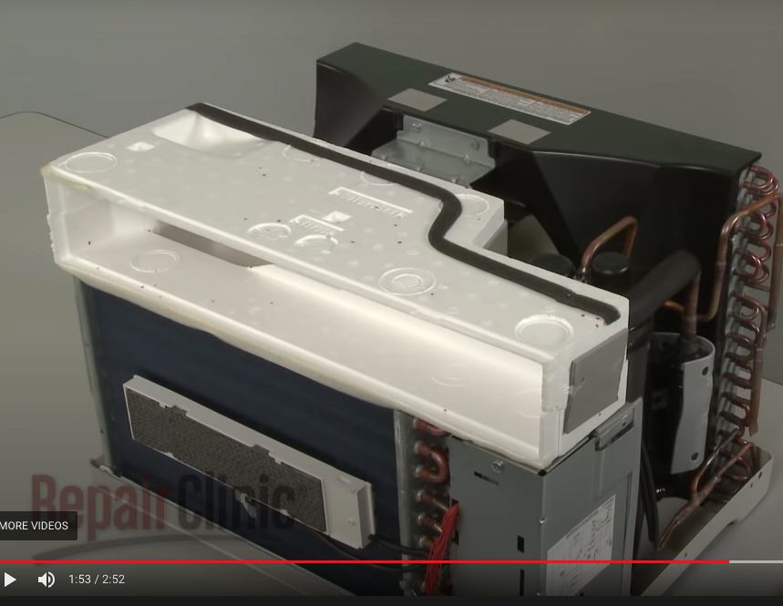

Test fixture: